Name:

ID:

M6 Makeup Assignment

Email completed assignment here: [nps.assumption@gmail.com](mailto:nps.assumption@gmail.com)

Part 1:

1. Create the following using HTML, CSS, and JavaScript. When you hover over each element in the table, the background color should change to cyan. The names should be colored red and be bold. The countries should be colored orange and italicized:

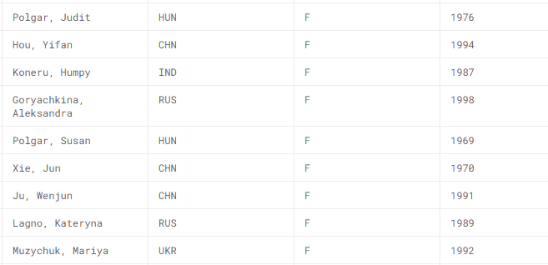

1. Create the following with HTML, CSS, and JavaScript. When you click on each box, the background color of the web page should change to the color written on the box:

Before click:

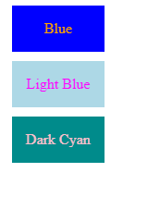

After clicking on each color:

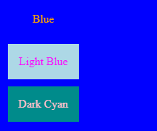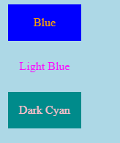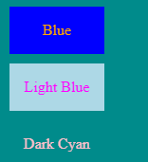

1. Create the following using HTML, CSS, and JavaScript. When you hover over each element in the periodic table, the background color should change to yellow:

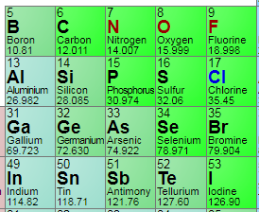

1. Create the following using HTML, CSS, and JavaScript. When you click on the orange ellipse it should change color from orange to pink:

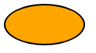

1. Use HTML, CSS, and Javascript to create the following. Whatever the user types in the text input box should be displayed in an h2 element above the text-input:

Before:



After:

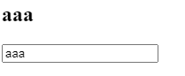

Part 2: Multiple choice

1. Which of the following makes comments for Javascript:

|  |  |
| --- | --- |
| <!-- ->  /**/ | <!-- -> |
| # | //  /**/ |
| “”” “”” | “”” “””  # |
| “” | -> |

1. Which of the following generates a random integer in javascript:

|  |  |
| --- | --- |
| Math.integer() | ˜ ˜(Math.random() * 1000) |
| parseInt(Random()) | Math.random() |
| Math.random() * 1000 | Randint() |
| Integer() | Random integer() |

1. What type of HTML tag is used for holding JavaScript code?

|  |  |
| --- | --- |
| Table | H1 |
| Code | Script |
| Link | a |
| div | style |

1. Consider the following HTML:

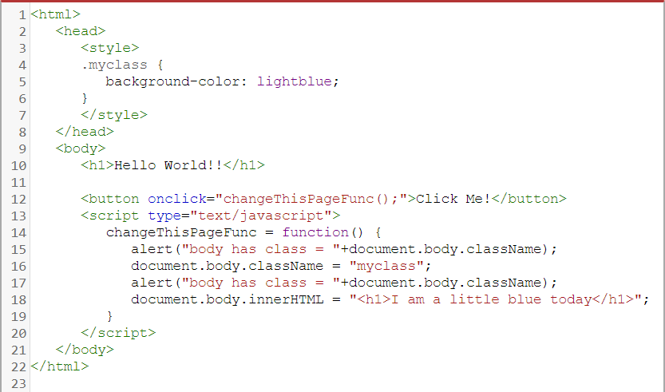

* What HTML element will turn light blue if the button is clicked?

|  |  |
| --- | --- |
| P | Button |
| Style | Head |
| H1 | H2 |
| Div | body |

1. Passwords, Check boxes, and Radios all use what HTML tag? What attribute needs to be specified to determine how it will look?

|  |  |
| --- | --- |
| H1, height | Div, quality |
| Table, border | Ol, padding |
| Form, size | Form, type |
| Input, type | Img, src |
| link, href | Iframe, href |

1. What does the alert box say?

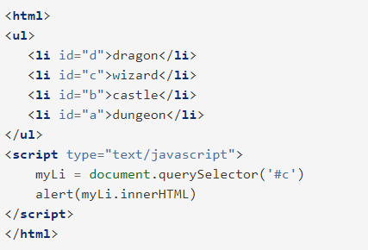

|  |  |
| --- | --- |
| #c | c |
| myLi.innerHTML | dragon |
| dragon wizard castle dungeon | d c b a |
| <li id=”c”>wizard</li> | wizard |

1. Match the following events:
2. Onkeyup
3. Onkeydown
4. Onkeypress

|  |  |
| --- | --- |
| Event | Definition |
|  | User releases a key |
|  | User presses shift + a |
|  | User presses space bar |